Forces online activity Name: ________________________
1. Go to this website, put the subtitles on and watch.
http://www.bbc.co.uk/schools/ks3bitesize/science/energy_electricity_forces/forces/activity.shtml

2. Go to this website, read the pages and answer the questions.
http://www.bbc.co.uk/bitesize/ks2/science/physical_processes/forces/read/1/

1. What are forces measured in? ___________________
2. Unbalanced forces ___________ the way something is moving.
3. What is the force that makes things fall to the ground on Earth? _______________
4. What is mass measured in? __________________________
5. Is mass a force? _______________
6. Write a definition for ‘weight’
__________________________________________________________________________
__________________________________________________________________________
7. What is another name for a forcemeter? ________________________
8. Forces are shown by ____________ in diagrams. The direction of the arrow shows the ________________ in which the force is acting. The ______________ the arrow, the bigger the force.
9. Will an object change its motion if two balanced forces are acting on the object? ______
10. Unbalanced forces do change the way something is moving – True or False
11. List the four things unbalanced forces can make objects do.
__________________________________________________________________________
__________________________________________________________________________
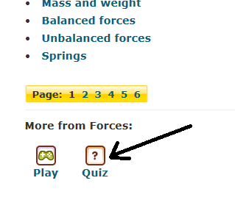
3. Complete the quiz. Keep doing the quiz until you get 10/10 correct.

4. Play the game.
You may have to select the older version of the game.


